Microservices Architecture using ASP.NET Core Web API
Hands-on: Microservices – JWT

Aim: To implement JWT (JSON Web Token) authentication in an ASP.NET Core Web API application and secure API endpoints using the Authorize attribute.
Theory:
JWT (JSON Web Token): JWT is a secure and compact token used to authenticate users and authorize access to protected resources. It contains user information in an encrypted format and is digitally signed to prevent tampering.
Authentication and Authorization: Authentication verifies the identity of a user, while authorization determines whether the authenticated user has permission to access a particular resource.
Bearer Token: A Bearer token is a JWT sent in the HTTP Authorization header to access protected API endpoints.
Authorize Attribute: The [Authorize] attribute restricts API access to authenticated users only.

Procedure:
- Create an ASP.NET Core Web API project.
- Install the Microsoft.AspNetCore.Authentication.JwtBearer NuGet package.
- Configure JWT settings in appsettings.json and Program.cs.
- Create the User model and AuthController.
- Generate a JWT token using the Login API.
- Secure the EmployeeController using the [Authorize] attribute.
- Run the application and test the APIs using Swagger.

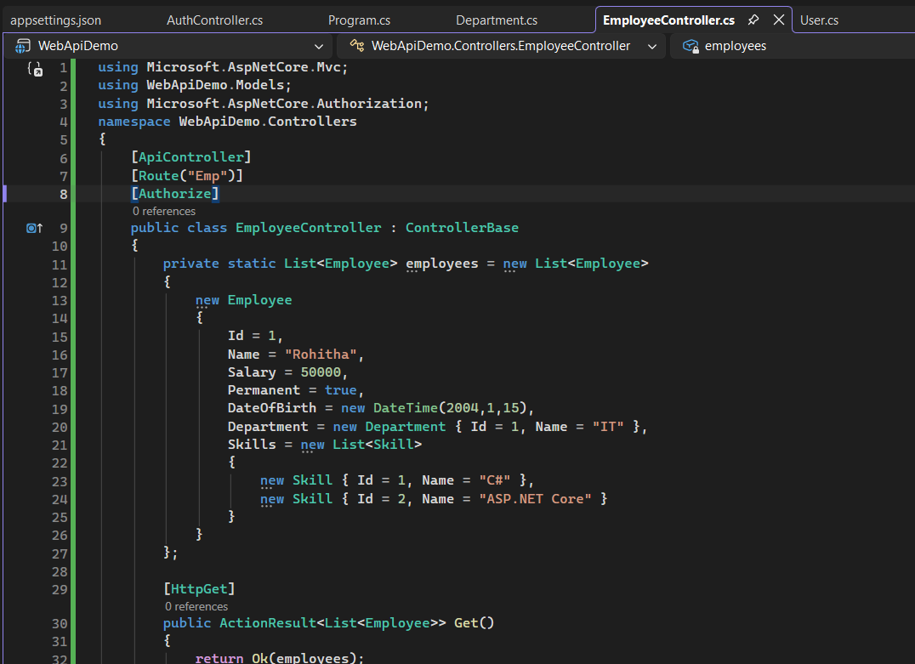
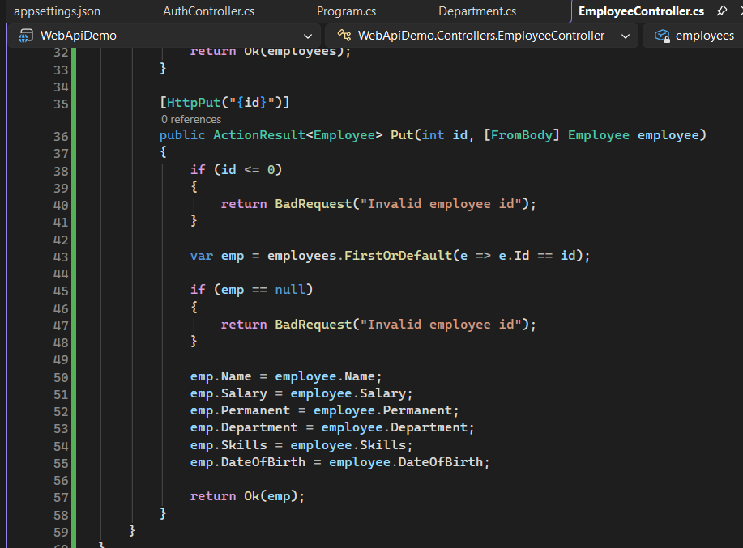
EmployeeController.cs:

Appsettings.json:
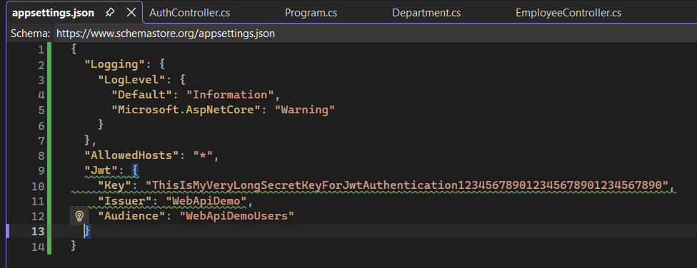
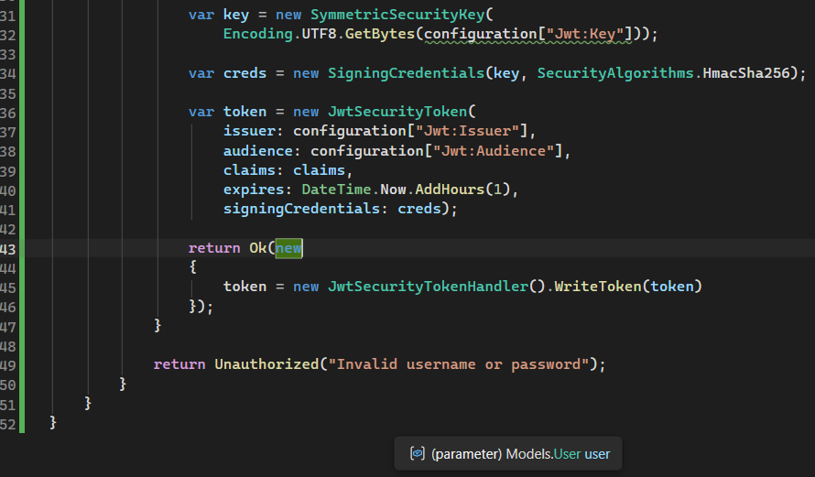
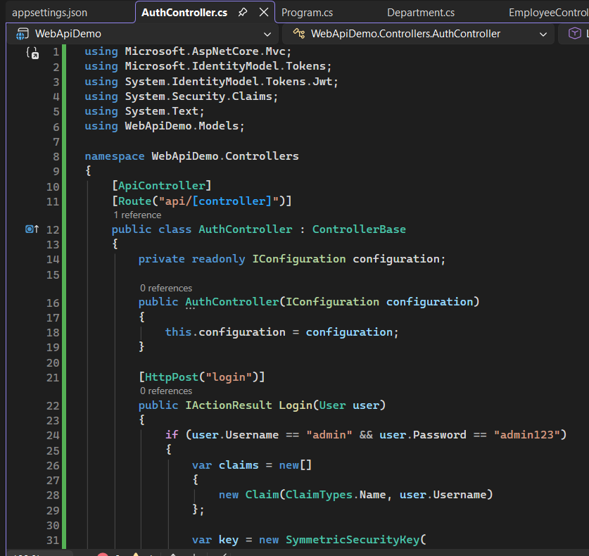
AuthController.cs:

Program.cs:
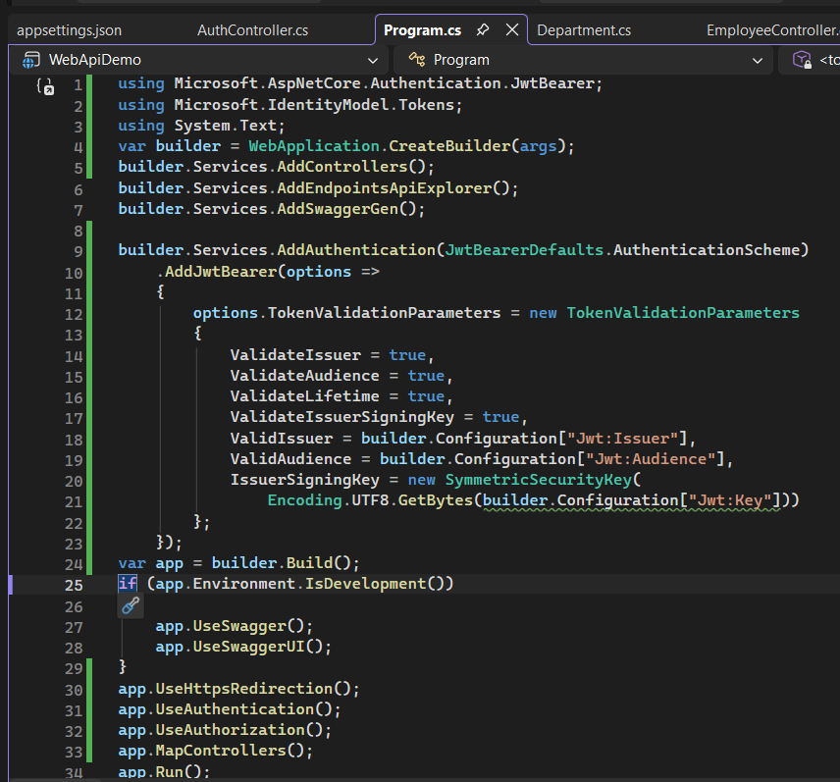

User.cs:
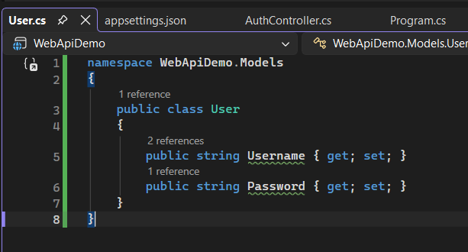

Output:
POST /api/Auth/login
